**HOPE JUNIOR SCHOOL.**

**END OF TERM 3 EXAMINATION -2024 .**

**TOP CLASS.Social Development.**

Name: \_\_\_\_\_\_\_\_\_\_\_\_\_\_\_\_\_\_\_\_\_\_\_\_\_\_\_\_\_\_\_\_\_\_\_\_\_\_\_

Class: \_\_\_\_\_\_\_\_\_\_\_\_\_\_\_\_\_\_\_\_\_\_\_\_\_\_\_\_\_\_\_\_\_\_\_\_\_\_\_\_

1. **Name things in class.**

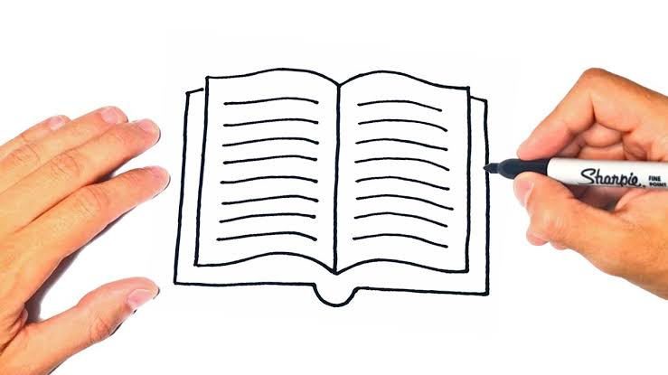 \_\_\_\_\_\_\_\_\_\_\_ \_\_\_\_\_\_\_\_\_

HH01672_\_\_\_\_\_\_\_\_\_\_ 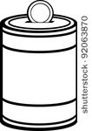\_\_\_\_\_\_\_\_\_\_

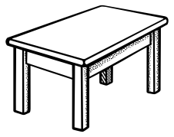\_\_\_\_\_\_\_\_\_\_

1. **Read and draw domestic animals.**

cow sheep

goat dog

cow pig

1. **Fill in the missing letter**

ch\_\_\_rch m\_\_\_sque

sch\_\_\_ \_\_\_l hosp\_\_\_\_tal

g\_\_\_\_rden m\_\_rket

polic\_\_\_ station

1. **Match correctly**

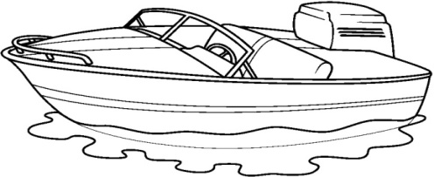 train

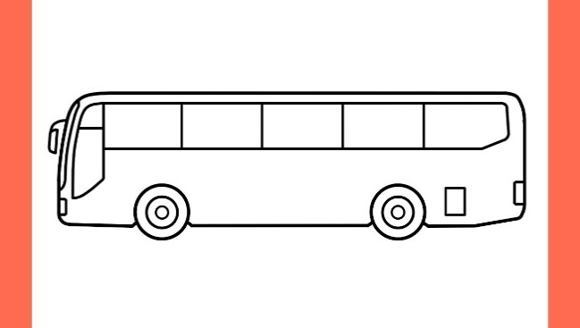 lorry

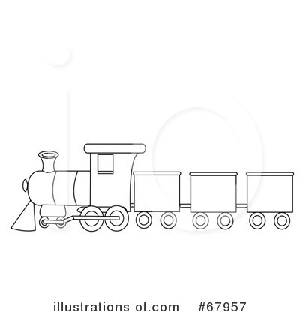 car

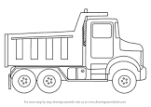 boat

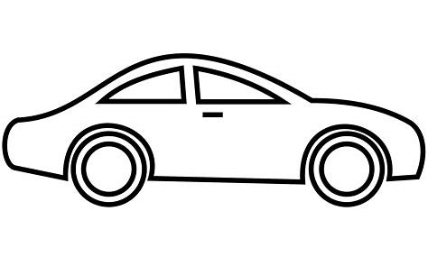 bus

1. **Read and circle for a picture.**

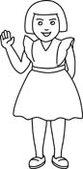 sister stone

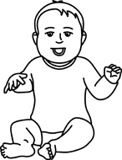 ball baby

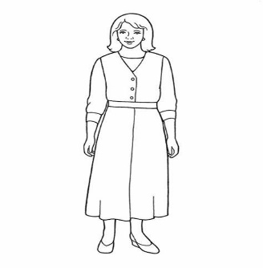 mother man

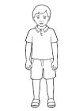 broom brother

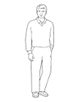 father fan

1. **Colour a picture for a given word.**

|  |
| --- |
| farmer |
| teacher ANd9GcRZsU1Wja90uYz6VOvM2LADVSPVJi-ICM2WrxLwSeo0g_ocTE-ggA https://encrypted-tbn1.gstatic.com/images?q=tbn:ANd9GcSE6NfycjHYvdZsLvd3ReYaA1uhrMDr4F5Ipk3fuX41IPWmltujlw |
| nurse ANd9GcSSFOgBz_xo6Vh8Q4Ea-BEaXOzSz75NEye5gmcbgYuueB__qcDm |
| priest C:\Users\ACER\Desktop\picture\IMG_6742.JPG Image result for sister images black and white |

1. **Orals**
2. What is the colour of your uniform?
3. Who treats sick people?
4. What is the colour of the sky?
5. What do you use to clean your nose?
6. Who heads a school?
7. A teacher uses \_\_\_\_\_\_to write on the chalkboard.
8. How many colours does the Uganda flag have?
9. Who is your friend?